Docker Documents

https://docs.docker.com/get-started/

- Guides
- Product manuals
- Glossary
- Reference
- Samples

Get Started, Part 1: Orientation and setup
Estimated reading time: 4 minutes
- 1: Orientation
- 2: Containers
- 3: Services
- 4: Swarms
- 5: Stacks
- 6: Deploy your app
Welcome! We are excited that you want to learn Docker. The Docker Get Started Tutorial teaches you how to:
- Set up your Docker environment (on this page)
- Build an image and run it as one container
- Scale your app to run multiple containers
- Distribute your app across a cluster
- Stack services by adding a backend database
- Deploy your app to production

Docker concepts
Docker is a platform for developers and sysadmins to develop, deploy, and run applications with containers. The use of Linux containers to deploy applications is called containerization. Containers are not new, but their use for easily deploying applications is.
Containerization is increasingly popular because containers are:
- Flexible: Even the most complex applications can be containerized.
- Lightweight: Containers leverage and share the host kernel.
- Interchangeable: You can deploy updates and upgrades on-the-fly.
- Portable: You can build locally, deploy to the cloud, and run anywhere.
- Scalable: You can increase and automatically distribute container replicas.
- Stackable: You can stack services vertically and on-the-fly.
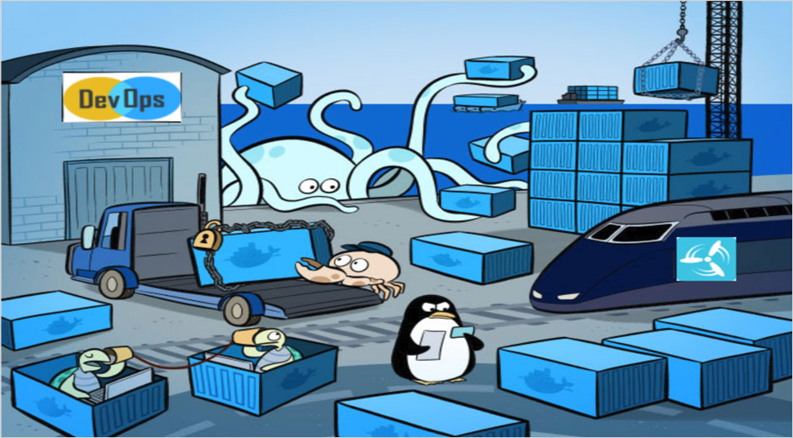

Images and containers
A container is launched by running an image. An image is an executable package that includes everything needed to run an application--the code, a runtime, libraries, environment variables, and configuration files.
A container is a runtime instance of an image--what the image becomes in memory when executed (that is, an image with state, or a user process). You can see a list of your running containers with the command, docker ps, just as you would in Linux.

Containers and virtual machines
A container runs natively on Linux and shares the kernel of the host machine with other containers. It runs a discrete process, taking no more memory than any other executable, making it lightweight.
By contrast, a virtual machine (VM) runs a full-blown “guest” operating system with virtual access to host resources through a hypervisor. In general, VMs provide an environment with more resources than most applications need.
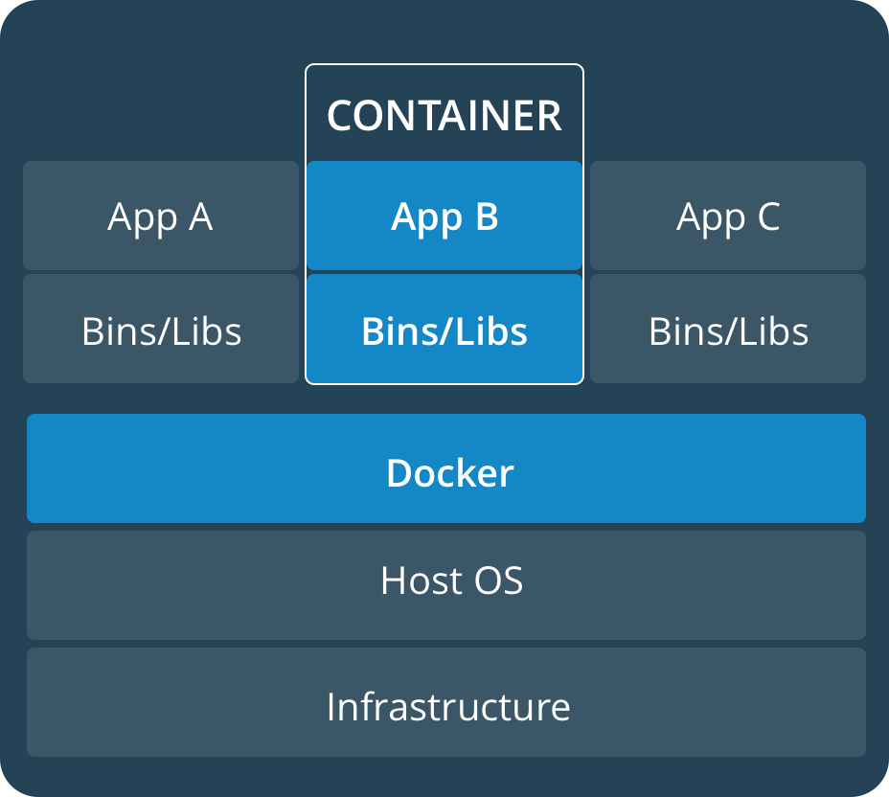 | 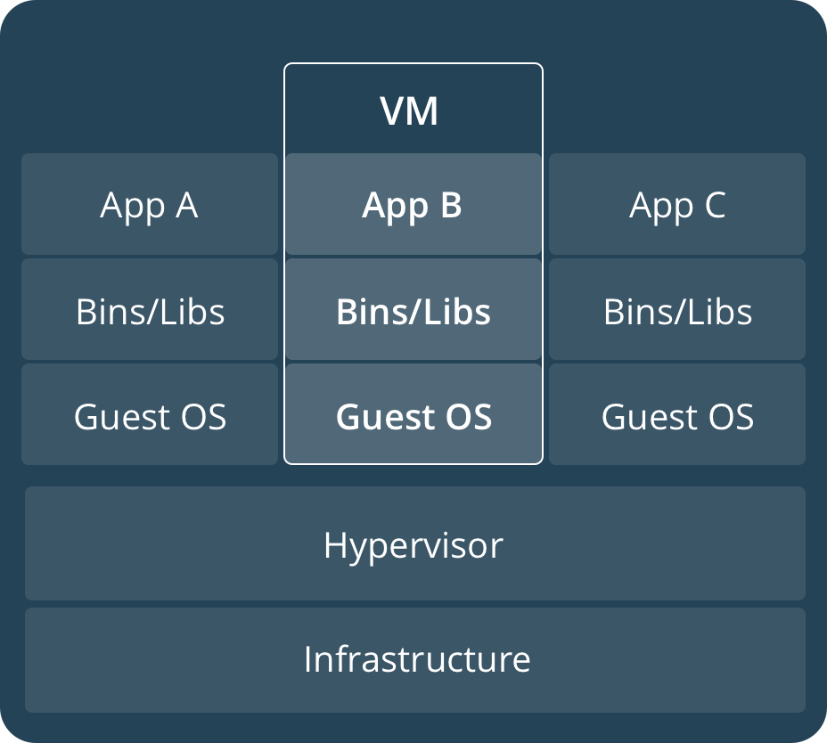

Prepare your Docker environment
Install a maintained version of Docker Community Edition (CE) or Enterprise Edition (EE) on a supported platform.
For full Kubernetes Integration
- Kubernetes on Docker for Mac is available in 17.12 Edge (mac45) or 17.12 Stable (mac46) and higher.
- Kubernetes on Docker for Windows is available in 18.02 Edge (win50) and higher edge channels only.
Install Docker

Test Docker version
- Run docker --version and ensure that you have a supported version of Docker:
docker --version

Docker version 17.12.0-ce, build c97c6d6
- Run docker info or (docker version without --) to view even more details about your docker installation:
docker info

Containers: 0
Running: 0
Paused: 0
Stopped: 0
Images: 0
Server Version: 17.12.0-ce
Storage Driver: overlay2
...
To avoid permission errors (and the use of sudo), add your user to the docker group. Read more.

Test Docker installation
- Test that your installation works by running the simple Docker image, hello-world:
docker run hello-world

Unable to find image 'hello-world:latest' locally
latest: Pulling from library/hello-world
ca4f61b1923c: Pull complete
Digest: sha256:ca0eeb6fb05351dfc8759c20733c91def84cb8007aa89a5bf606bc8b315b9fc7
Status: Downloaded newer image for hello-world:latest

Hello from Docker!
This message shows that your installation appears to be working correctly.
...
- List the hello-world image that was downloaded to your machine:
docker image ls
- List the hello-world container (spawned by the image) which exits after displaying its message. If it were still running, you would not need the --all option:
docker container ls --all

CONTAINER ID IMAGE COMMAND CREATED STATUS
54f4984ed6a8 hello-world "/hello" 20 seconds ago Exited (0) 19 seconds ago

Recap and cheat sheet
## List Docker CLI commands
docker
docker container --help

## Display Docker version and info
docker --version
docker version
docker info

## Execute Docker image
docker run hello-world

## List Docker images
docker image ls

## List Docker containers (running, all, all in quiet mode)
docker container ls
docker container ls --all
docker container ls -aq

Conclusion of part one
Containerization makes CI/CD seamless. For example:
- applications have no system dependencies
- updates can be pushed to any part of a distributed application
- resource density can be optimized.
With Docker, scaling your application is a matter of spinning up new executables, not running heavy VM hosts.
On to Part 2 >>
get started, setup, orientation, quickstart, intro, concepts, containers

Rate this page:

1938
226

- Get Docker
  - Overview of Docker editions
  - Docker CE
  - Docker EE
  - Compatibility between Docker versions
- Get started
  - Get started with Docker
    - Part 1: Orientation
    - Part 2: Containers
    - Part 3: Services
    - Part 4: Swarms
    - Part 5: Stacks
    - Part 6: Deploy your app
  - Docker overview
- Develop with Docker
  - Develop your apps on Docker
    - App development overview
    - App development best practices
    - Develop images
    - Docker app examples
  - Develop using the Docker Engine SDKs and API
    - Overview
    - SDK and API examples
- Configure networking
  - Networking overview
  - Use bridge networks
  - Use overlay networks
  - Use host networking
  - Use Macvlan networks
  - Disable networking for a container
  - Networking tutorials
  - Configure the daemon and containers
  - Legacy networking content
- Manage application data
- Run your app in production
- Standards and compliance
- Open source at Docker
- Documentation archive
- Edit this page
- Request docs changes
- Get support

On this page:
- Docker concepts
  - Images and containers
  - Containers and virtual machines
- Prepare your Docker environment
  - Test Docker version
  - Test Docker installation
- Recap and cheat sheet
- Conclusion of part one
- What is Docker
- What is a Container
- Use Cases
- Customers
- Partners
- For Government
- About Docker
- Management
- Press & News
- Careers
- Product
- Pricing
- Community Edition
- Enterprise Edition
- Docker Datacenter
- Docker Cloud
- Docker Store
- Documentation
- Learn
- Blog
- Training
- Support
- Knowledge Base
- Resources
- Community
- Open Source
- Events
- Forums
- Docker Captains
- Scholarships
- Community News
- Status
- Security
- Legal
- Contact
Copyright © 2018 Docker Inc. All rights reserved.
- Twitter
- Youtube
- Google
- Github
- Linkedin
- Facebook
- Reddit
- Slideshare

